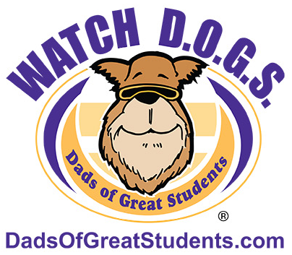 | Watch D.O.G.S. Pizza Night at Sunrise Elementary  - Kickoff Event -

What is Watch D.O.G.S. (Dads of Great Students)? Watch D.O.G.S. is a national program that encourages positive male role models in the school. Dads or adult father figures are encouraged to volunteer one day a school year in classrooms and around the school with various activities put together by school administration.

Who is a Watch D.O.G.? Any male that has positive relationship with a Sunrise student – Dad, Stepdad, Grandpa, Uncle, big brother, etc.

Join us for pizza, information regarding this fabulous opportunity, and the opportunity to schedule your day at Sunrise.
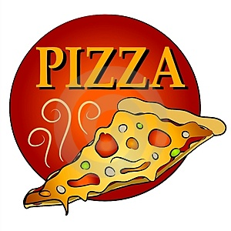
WHEN: Wednesday, December 11, 2019
TIME: 6:15 – 7:15 PM
WHERE: Sunrise Elementary Cafeteria
WHO: Dad, Stepdad, Grandpa, Uncle, and Sunrise students

In order to participate, you need to do two things:
- Fill out the bottom portion of this slip and return it with your student (ASAP) saying that you will attend the pizza night so we will have an accurate head count for the food.
- Mark your calendars, and we will see you Wednesday, December 11, 2019.

Please RSVP by Monday, December 9, 2019 by returning the slip below or emailing Nicole.Peterson@ahschools.us Please Return to Nikki Peterson, Volunteer Services Coordinator

_____Yes – We Will Be There! (#) _____ of “Dad” and students attending

Father/Father-Figure Name _____________________________ Email_________________________________
Phone(s): Home ______________________________________ Cell __________________________________
Student’s Name __________________________________ Teacher’s Name ____________________________
Student’s Name __________________________________ Teacher’s Name ____________________________
Student’s Name __________________________________ Teacher’s Name ____________________________

